Isaac

[Email address]

This document covers all of the major/noteworthy contributions I made to the project this semester across each sprint.

personal Portfolio

Isaac flello, 9492917, group 4

## Release 1:

## Task 1

Sprint: 1  
Task: Designing the Database Schema  
Other people involved: Matthew  
Description: I worked with Matthew on creating the first schema for the database that would be used in the website. We started by deciding what tables the database would need, and what values those tables would have, before adding primary keys and foreign keys. This was a good opportunity for me to use the knowledge I gained in a previous semester when I did a unit about databases. We sketched out the original version of the database before sending it to Eirik, who implemented it in the actual product.

The database schema Matt and I ended up with

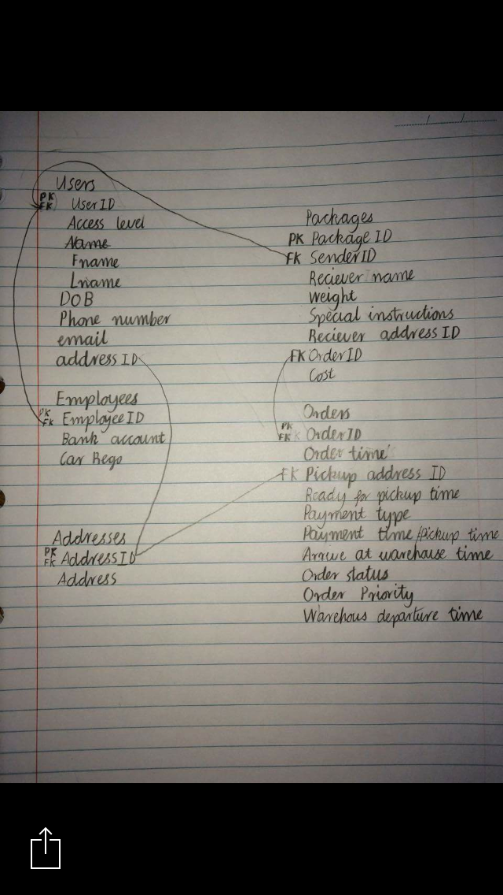

## Task 2

Sprint: 2  
Task: Creating a quote feature for the website  
Description: I chose to work on creating a feature for the website that would allow potential customers to get a quote on the cost of delivery for their package, before placing an actual order. It took me a while to finish implementing because it was my first time working on a website. Luckily, it involved the use of some cshtml, which allows for the use of common programming practices I have used before, such as performing basic mathematical operations with integers. In this case that meant I could implement a fairly simple mathematical formula which retrieves and uses values input by the user to calculate an accurate cost of delivery, considering the weight and dimensions of the package as well as the speed of delivery requested. I enjoyed working on this feature because I was able to use some existing knowledge as well as gain new knowledge completing it.  
To view this feature:  
Quote feature:  
PackageDelivery/Views/Home/Quote

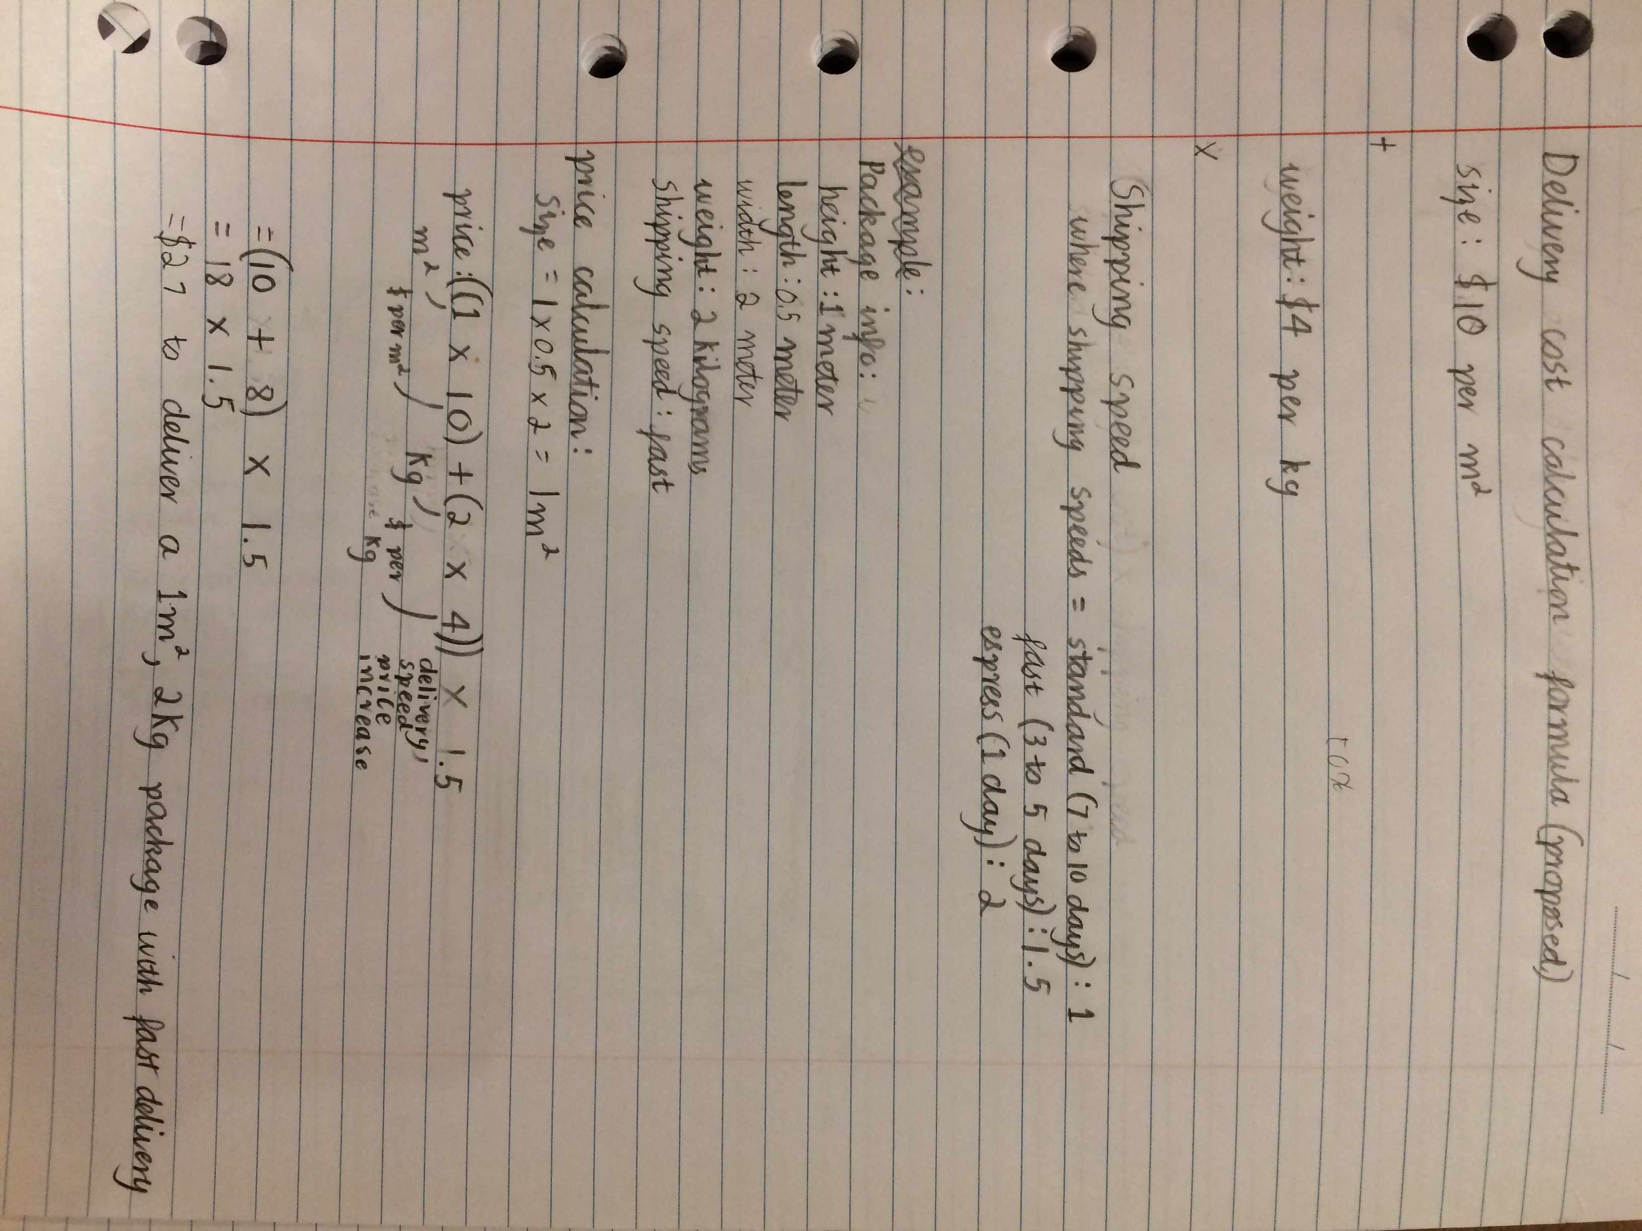

The diagram I sent to my group, the make sure they were happy with how I wanted to implement the feature

## Task 3

Sprint: 2  
Task: Writing the first Peer Review  
Description: I was in charge of creating the first peer review for our client team. I understand that the peer review is meant to be feedback from the entire team, but trying to have 6 people write one document is very unrealistic. I tried to get the impressions of my team members regarding our client team’s performance, then I gathered everything I wanted to say together before putting it in the review. I referred to the criteria frequently and put together a pretty good report. All together a day working on it, so I would say it was a small to medium sized task.

## Task 4

Sprint: 2  
Task: Creating sprints 3 and 4  
Description: At the end of sprint 2, I worked on creating the next two sprint plans. I tried to get input from my team members, but mostly they just agreed that I should just use my best judgement and clarify with them after I finished making it. I tried to learn from the previous two sprints when I was making the next two. I considered how much work we achieved per sprint in the past and tried to use that information to assign a reasonable amount of work in each new sprint  
To view this:  
See the Sprint and Release plan

## Task 5

Sprint: 1 & 2  
Task: Release 1 upload  
Description: This is a small task but I think it’s important enough for a mention. I was in charge of uploading the release 1 files, so I spent a day retrieving everything that was needed from my group members, and confirming things I was either unsure about or needed their input on.  
I retrieved the test suites, burndown charts, stories, sprint plans, and code and put it together into a zip file to upload.

## Release 2:

### Task 1:

Sprint: 4  
Task: Creating a today’s orders table  
Description: We had an existing page that allowed admins to view the packages that needed picking up for the day, but I wanted to change it to also show orders that needed delivering today. It sounds like a simple task but in order to properly implement it I needed to add new rows to tables in the database. That in turn meant I had to edit several different parts of the website, specifically parts where database information is retrieved and where orders are created.  
The reason for this is because the database expects all fields in an order to be filled in. I added new fields to the database to enable a “start delivery” value to be calculated. However, after doing this the rest of the website still didn’t know where to get the values for those fields from, which meant that trying to place an order caused a crash. This caused a lot of frustration but I managed to get it working over about 5 days. The fact that this is the first website I have worked on also made it take a while. Working on this feature really gave me a better understanding of how a lot of the other code works, since I had to trawl through it all in order to find out how to implement a solution for the issue I was having.  
To see this feature:  
Today’s orders feature: PackageDelivery/Areas/Admin/Views/Home/TodaysOrders  
The orders table in the database: PacakgeDelivery/models/dbtables (line 92)

### Task 2:

Sprint: 3  
Task: Creating an about page for the website  
Description: This was a fairly simple task, it involved me creating an about page for the website. It contains a description of the company, and an FAQ section. I used the FAQ section to answer questions people might have about the webpage, as well as explain things that might not be explicitly explained elsewhere. This includes things like what the procedure is for package pickup and where the delivery company picks up and delivers. The page also links to relevant pages where necessary.  
I forgot I had done this feature until near the end of sprint 4, which is when I pushed it into the GitHub repository.  
To see this feature:  
The about feature: PackageDelivery/Views/Home/About

### Task 3:

Sprint: 3  
Task: Create a sticker generation feature for orders  
Description: I created a feature for the website which can automatically create stickers for orders. The sticker shows information about the order, including the packages weight and dimensions, the delivery cost, and the sender’s and receiver’s names and addresses. I made the feature accessible wherever packages were listed on the website, which at the time was on the “Orders” page. Each order in the list had a “sticker” button, and pressing it would take the user to a new page displaying the sticker for the order. I was able to learn a lot of useful information by studying other parts of the website made by Eirik, such as the search mechanism in the orders page.  
To view this feature:  
Sticker Creator feature: PacakgeDelivery/Areas/Admin/Views/Home/StickerMaker  
Button to create sticker: PackageDelivery/Areas/Admin/Views/Home/Orders (line 58)

The diagram I created to show my group members what I wanted the stickers to look like

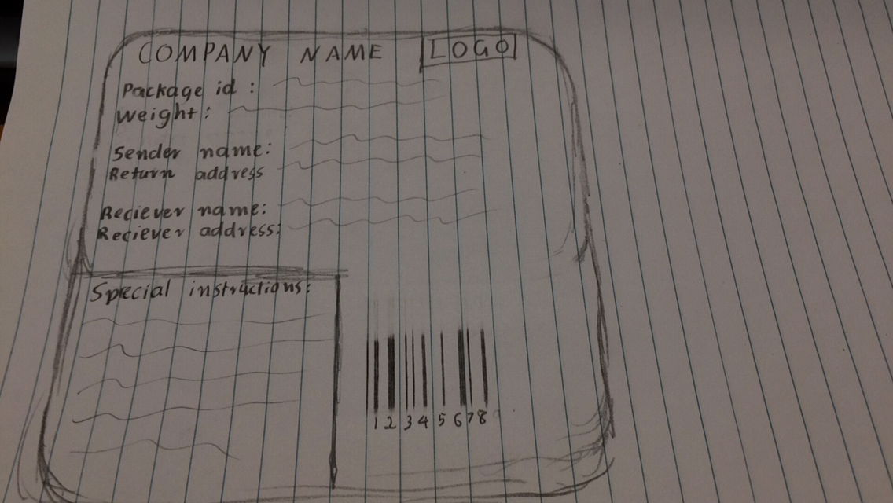

### Task 4:

Sprint: 4  
Task: Improving the sticker feature  
Description: I wanted to improve the sticker feature, so I make a couple of changes to it. The first thing I added was a print feature. This featured the addition of a “print” button on the page where the sticker is displayed, which creates a new tab and displays the sticker there. The new tab has no background layout, so the user can use the keyboard shortcut “ctrl + p” to print the sticker, without anything else being printed with it. There are some minor differences between the sample sticker and the printable version, mostly just the removal of irrelevant information.  
I also added buttons in the admin area wherever packages are displayed to allow printing of stickers for orders.  
To view this feature:  
printable sticker: packageDelivery/Areas/Admin/Views/Home/PrintableStickerMaker

## Task 5:

Sprint: 3 and 4  
Task: Uploading  
Description: I was responsible for the upload for release 2 as well. Once again I had difficulties trying to retrieve everything I needed from all of the group members so it took an entire day to get everything together. There was also a lot of clarification between me and the other members this time, but I think that’s a really good thing, because people were working together more than previously.